Data Handling and Visualization (DSA06)
Name: Prasanna M Reg. No: 1925260244
Set 28: Vehicle Performance Analysis
Question 1. Using R, develop a violin plot to compare the distribution of Fuel_Efficiency across different Safety_Rating categories. Examine the spread, central tendency, and variability within each group, and interpret what this indicates about efficiency patterns.
Program (R):
library(ggplot2)
vehicle <- data.frame(Vehicle_ID = paste0("V", 1:5), Engine_Size = c(1.5,2.0,3.0,2.5,1.8),
Horsepower = c(110,150,250,200,130), Fuel_Efficiency = c(18,15,12,14,17),
Top_Speed = c(180,200,250,220,190), Safety_Rating = c(4,5,5,4,3))
ggplot(vehicle, aes(x = factor(Safety_Rating), y = Fuel_Efficiency, fill = factor(Safety_Rating))) +
geom_violin(trim = FALSE, alpha = 0.6) + geom_boxplot(width = 0.1, fill = "white") +
geom_jitter(width = 0.05) +
labs(title = "Fuel Efficiency by Safety Rating", x = "Safety Rating", y = "Fuel Efficiency (km/l)") +
theme_minimal() + theme(legend.position = "none")
Output:
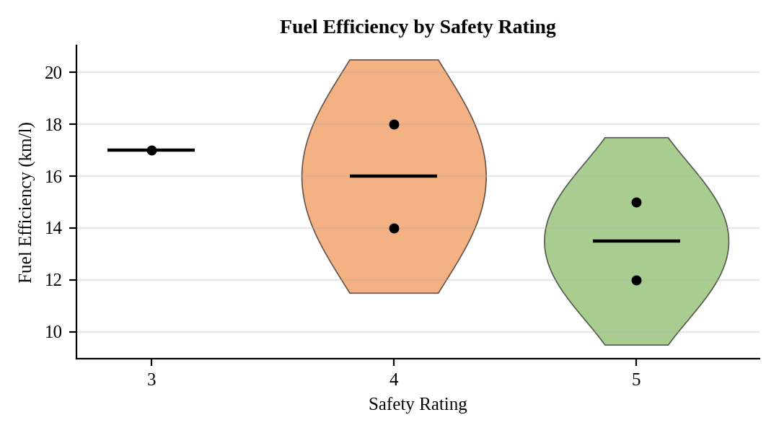
Interpretation:
Rating 5 has the lowest efficiency (mean 13.5 km/l, range 12 to 15), rating 4 has the widest spread (14 to 18, mean 16) and rating 3 has one vehicle at 17 km/l, so no violin can be drawn for it. Higher safety ratings go with lower fuel efficiency here, because the 5-star vehicles are the larger, more powerful ones. With one or two vehicles per group these shapes are only indicative.

Question 2. Using R, construct a scatter plot to explore the relationship between Horsepower and Top_Speed, applying color differentiation based on Engine_Size. Analyze the strength and direction of correlation and find observable performance trends.
Program (R):
ggplot(vehicle, aes(x = Horsepower, y = Top_Speed, colour = Engine_Size)) +
geom_point(size = 4) +
geom_smooth(method = "lm", se = FALSE, colour = "red", linetype = "dashed") +
scale_colour_viridis_c() +
labs(title = "Horsepower vs Top Speed", x = "Horsepower", y = "Top Speed (km/h)",
colour = "Engine Size (L)") +
theme_minimal()
cor(vehicle$Horsepower, vehicle$Top_Speed)
Output:
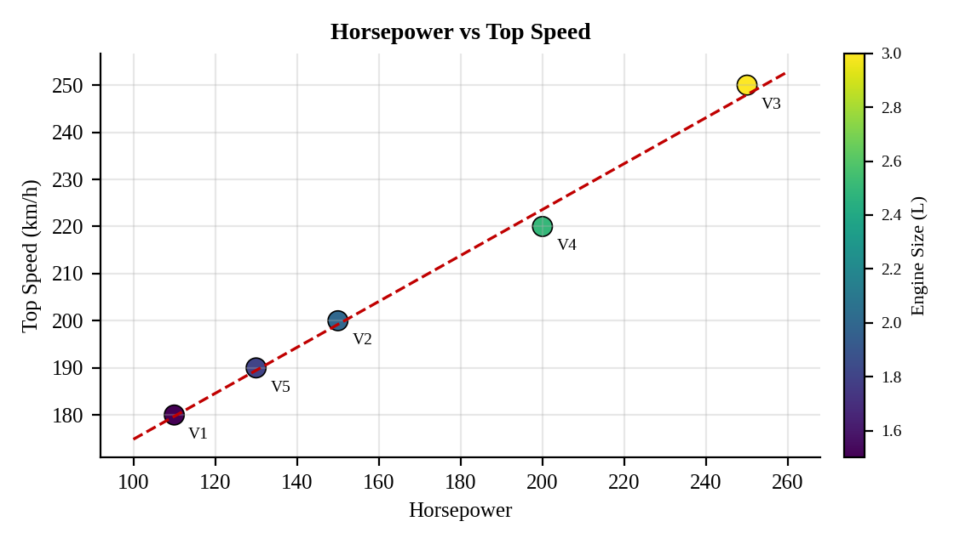
Interpretation:
The correlation is very strong and positive (r = 1.00). The fitted line adds about 0.49 km/h of top speed for every extra horsepower. The point colour changes from dark purple for the small 1.5 L engine (110 hp, 180 km/h) to yellow for the 3.0 L engine (250 hp, 250 km/h), so larger engines deliver more power and a higher top speed.

Question 3. Using R, create a correlation heatmap for all numerical variables in the dataset. Identify the variables most strongly associated with Top_Speed and their influence on overall vehicle performance.
Program (R):
library(reshape2)
num <- vehicle[, c("Engine_Size","Horsepower","Fuel_Efficiency","Top_Speed","Safety_Rating")]
cor_m <- round(cor(num), 2)
ggplot(melt(cor_m), aes(Var1, Var2, fill = value)) +
geom_tile(colour = "white") + geom_text(aes(label = value), size = 3) +
scale_fill_gradient2(low = "blue", mid = "white", high = "red", limits = c(-1, 1)) +
labs(title = "Correlation Heatmap", x = "", y = "", fill = "Correlation") +
theme_minimal() + theme(axis.text.x = element_text(angle = 30, hjust = 1))
Output:
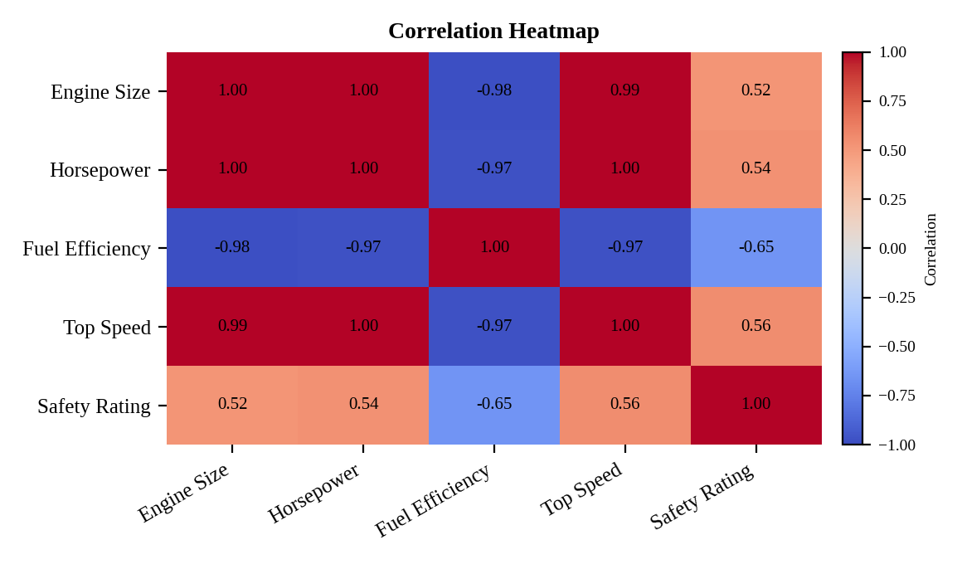
Interpretation:
Top Speed is most strongly related to Horsepower (r = 1.00) and Engine Size (r = 0.99), and strongly negatively related to Fuel Efficiency (r = -0.97); its link with Safety Rating is moderate (r = 0.56). Bigger, more powerful engines give higher speed but lower fuel efficiency, so performance and economy trade off against each other.

Question 4. In Tableau, design an interactive dashboard incorporating bar charts and scatter plots, along with filters for Engine_Size and Safety_Rating, to highlight vehicles that balance fuel efficiency and high performance. Provide analytical interpretation of the insights derived from the dashboard.
Procedure (Tableau):
1. Open Tableau, click Connect, choose Text file / Microsoft Excel, select "Vehicle_Performance.csv" and open Sheet 1.
2. Create a calculated field Balanced = [Fuel_Efficiency (km/l)] >= 15 AND [Top_Speed (km/h)] >= 200.
3. Sheet 1 (Bar): Columns = Vehicle_ID; Rows = SUM(Fuel_Efficiency); Color = Balanced; add labels. Add a second bar sheet for Horsepower if required.
4. Sheet 2 (Scatter): Columns = Fuel_Efficiency; Rows = Top_Speed; Detail = Vehicle_ID; Color = Balanced; Size = Horsepower; add reference lines at 15 km/l and 200 km/h.
5. Show the filters for Engine_Size (Range) and Safety_Rating (Multiple values) and apply them to all sheets.
6. Click New Dashboard, name it "Vehicle Performance Dashboard", set Size to Automatic and drag the sheets onto the canvas.
7. Select each chart and click the "Use as Filter" icon so that clicking a mark filters the other sheets; keep tooltips enabled.
8. Add a title to every sheet, adjust labels and colours, and save the workbook (File > Save As, .twbx).

Output:
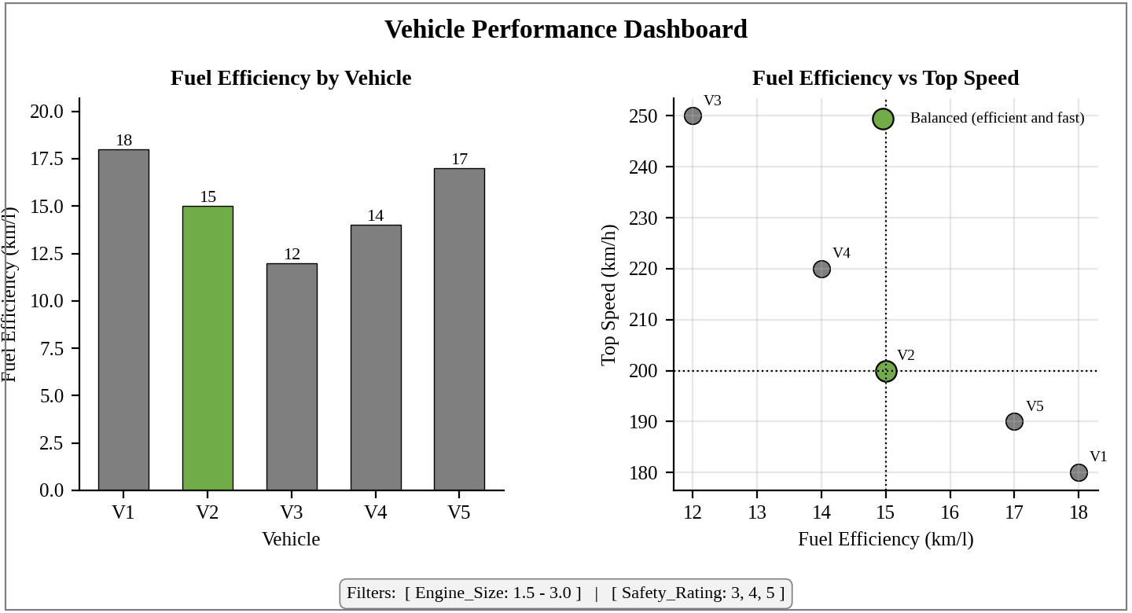
Dashboard layout (preview of the Tableau output).
Interpretation:
V2 is the only vehicle that is both efficient (15 km/l) and fast (200 km/h), and it also has a 5-star safety rating, so it is the best balance. V1 and V5 are the most efficient (18 and 17 km/l) but slower (180 and 190 km/h), while V3 and V4 are fastest (250 and 220 km/h) but least efficient (12 and 14 km/l). The filters let a buyer narrow the list by engine size or safety level.

